|  |  |  |  |
| --- | --- | --- | --- |
| Lab1 | | | |
| Project name |  | | |
| Document ref |  | | |
| Version |  | | |
| Release date |  | | |
| Author | Wu Fei | | |
| Classification |  | | |
| Distribution List |  | | |
| Approved by | Name | Signature | Date |
|  |  |  |  |



**Ming Hsieh Department of Electrical Engineering**

**University of Southern California, Los Angeles, CA 90089**

**Spring 2022**

**EE 477**

Revision History

|  |  |  |  |
| --- | --- | --- | --- |
| Date | Version | List of changes | Author + Signature |
|  |  |  |  |
|  |  |  |  |
|  |  |  |  |
|  |  |  |  |
|  |  |  |  |
|  |  |  |  |
|  |  |  |  |
|  |  |  |  |
|  |  |  |  |
|  |  |  |  |
|  |  |  |  |
|  |  |  |  |
|  |  |  |  |
|  |  |  |  |
|  |  |  |  |
|  |  |  |  |
|  |  |  |  |
|  |  |  |  |
|  |  |  |  |

C A T A L O G

1 Action items 1

1.1 Step1 1

2 Step2/step3 6

3 Step4/Step3 22

3.1 INV1X 22

3.2 INV4X 24

3.3 NOR1X 25

3.4 NOR4X 29

3.5 NAND1X 32

3.6 NAND4X 35

# Action items

## Step1

Measurement of k-ratio: Draw the schematic of an inverter in Cadence using minimum width (120nm) for the NMOS. Experiment with the PMOS width until the propagation delays are within 10% of each other, i.e.

 | Tphl − Tplh |  / min (Tphl, Tplh) < 0.1

Then calculate k = WPMOS/WNMOS

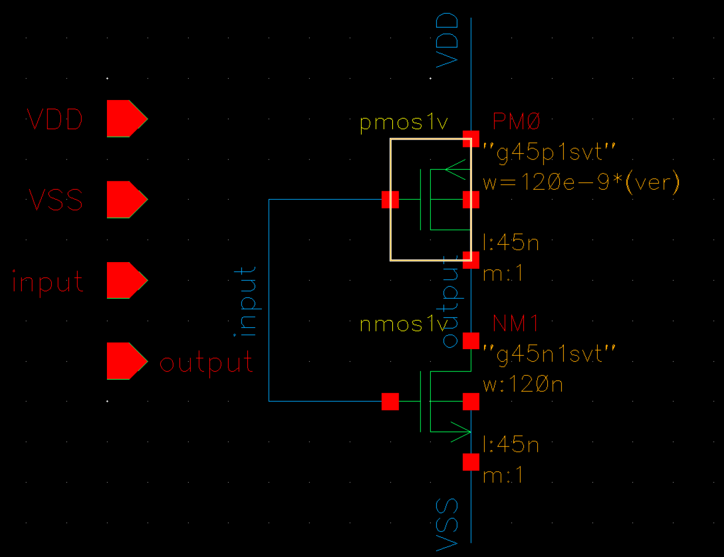

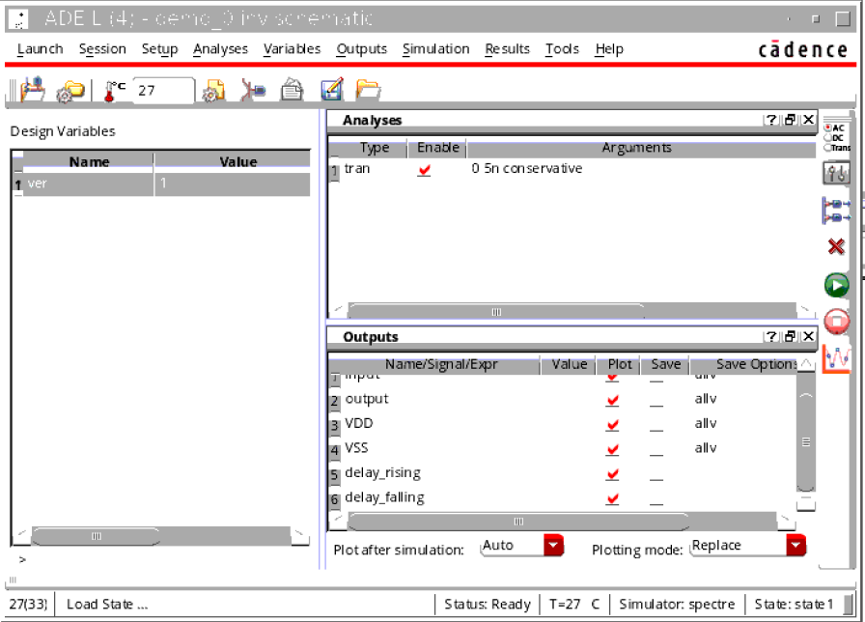

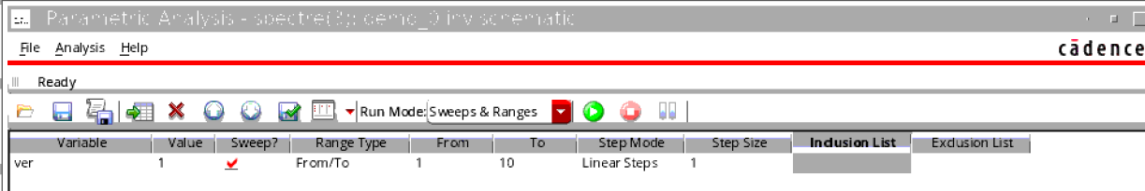

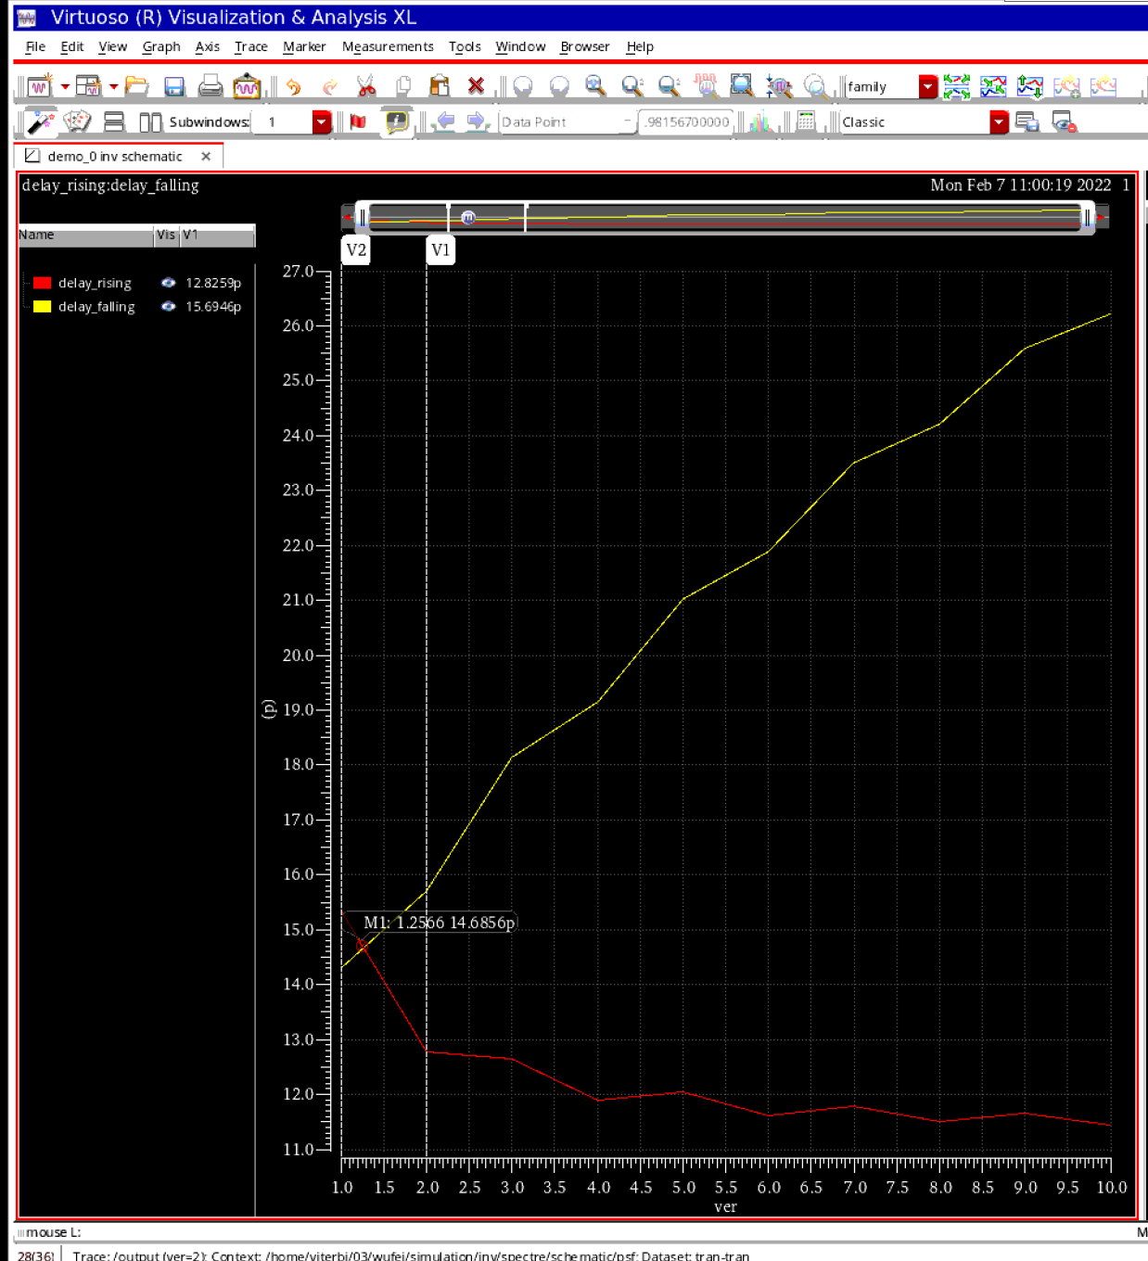

Showing as the delay in different ver value, it is clear that the best choice is the ver is equal to 1.

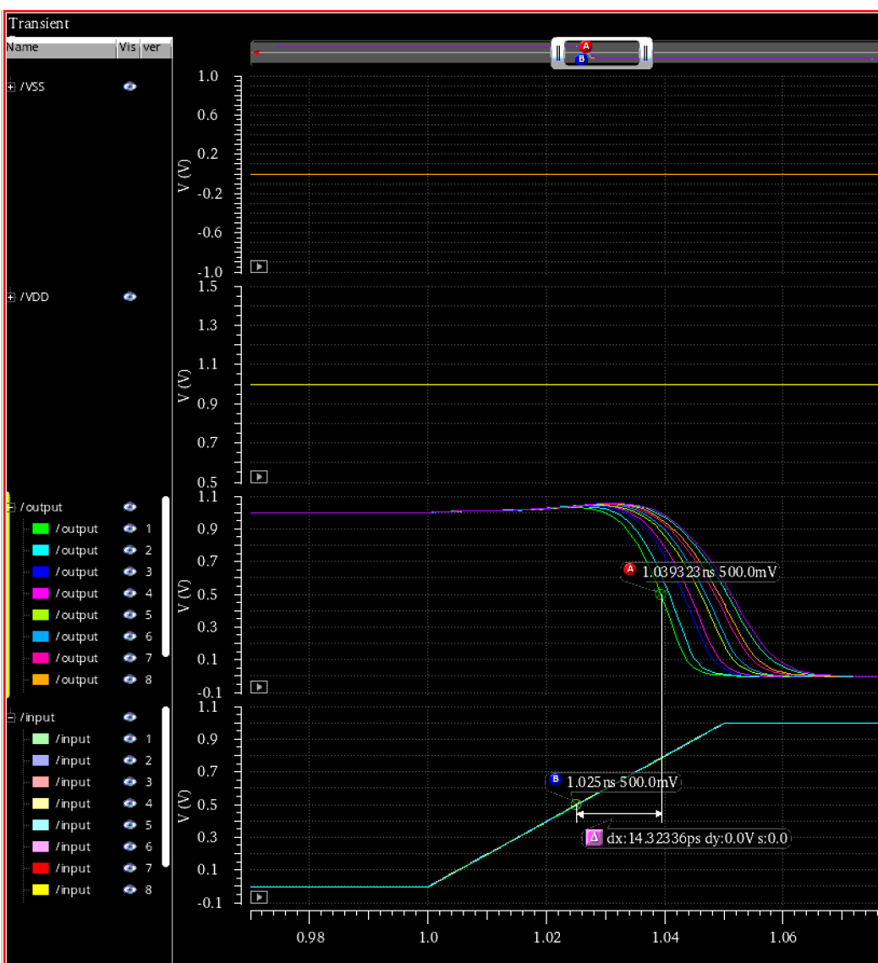

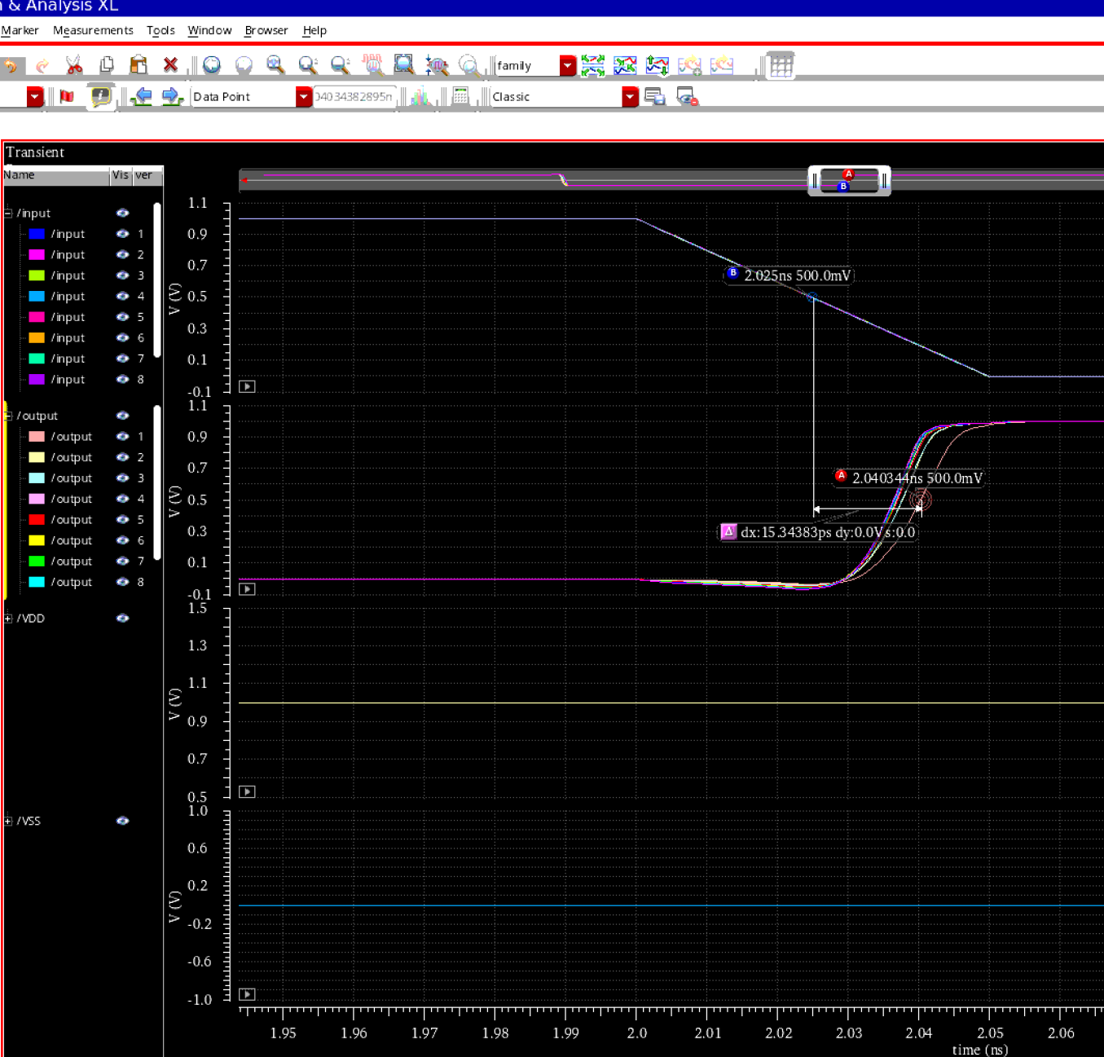

# Step2/step3

Schematic design and delay measurement of gates: Whatever you calculated in Step 1, use k=2 from here on to maintain consistency.

* Design an inverter schematic with WNMOS = 120nm and WPMOS = 240nm. This is INV_1X.

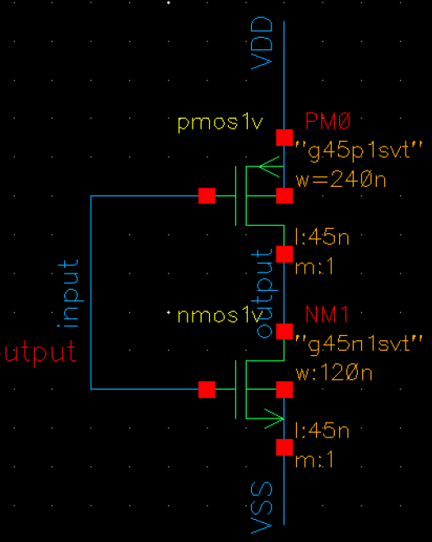

* Design another inverter with both NMOS and PMOS 4 times as big as INV_1X. This is INV_4X.

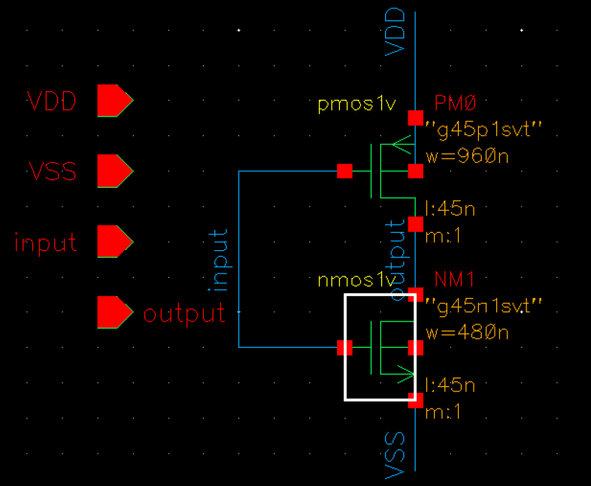

* Design NAND2_1X, NAND2_4X, NOR2_1X and NOR2_4X.

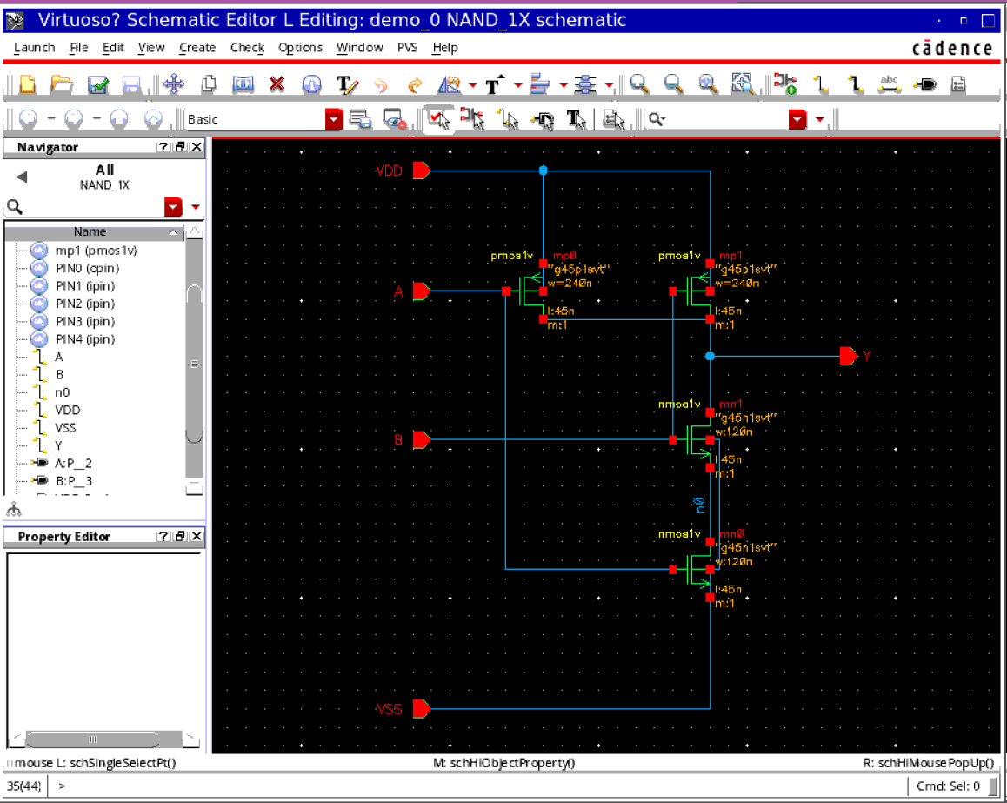

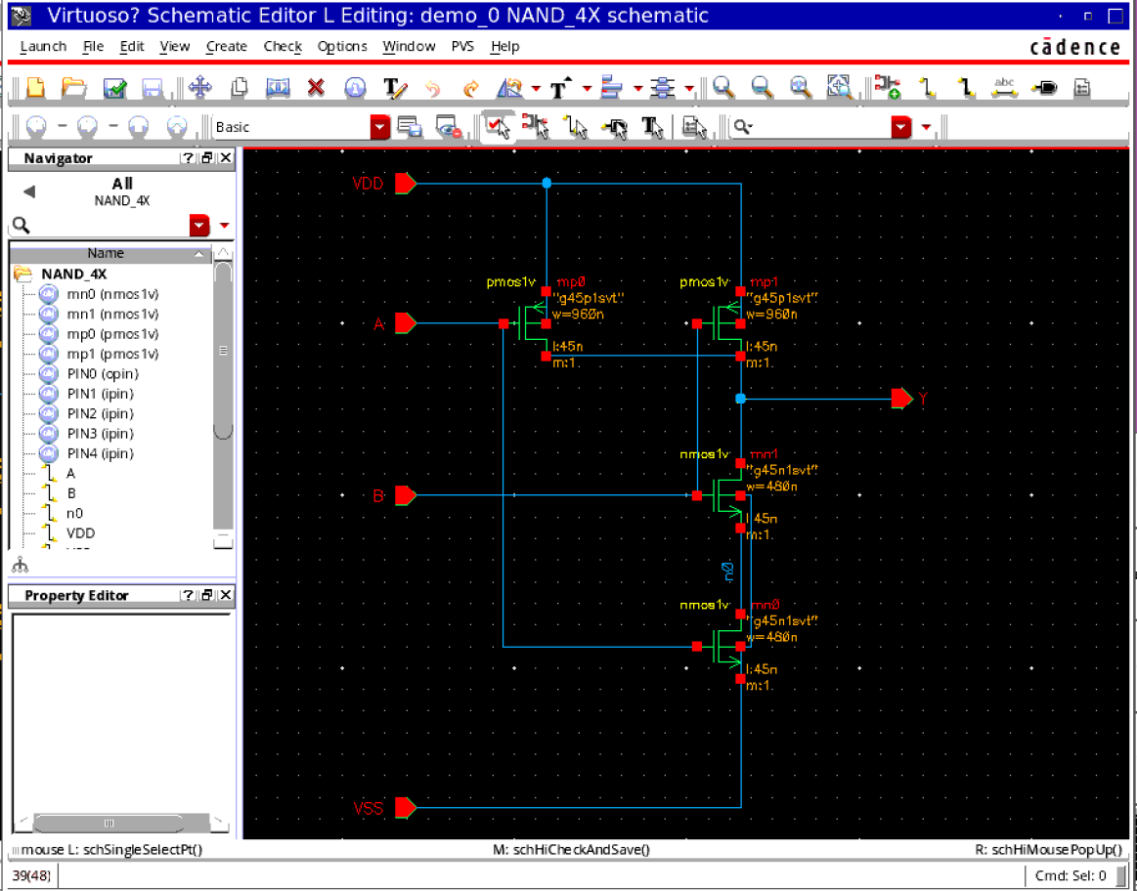

In each case, size the transistors so that the worst case propagation delays are equal to the corresponding inverter (e.g. τPLH and τPHL for NOR2_4X should be equal to those of INV_4X). Remember to check different cases to find the worst case delay.

Detecting the delay of inv_4x show like following:

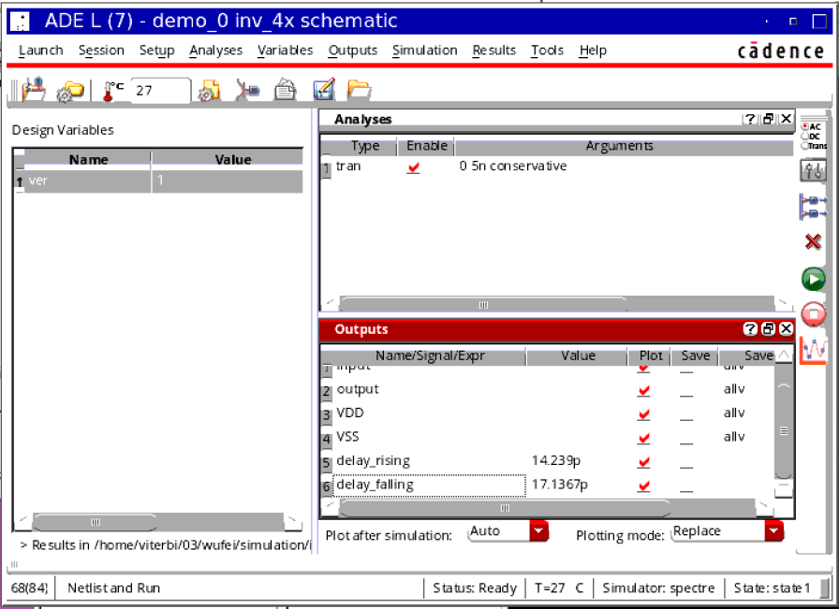

Theoretically, in the worst situation, there is only one PMOS to drive the output and one NMOS to drive the output, so we set the size of the MOS 2 times to the INV4x to get the close delay time required:

For NAND the worst situation should be ab00->ab01/ab10

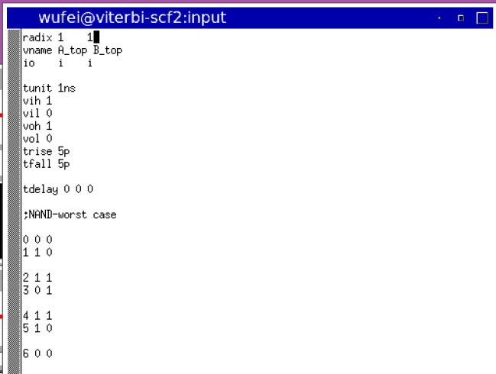

NAND1x:

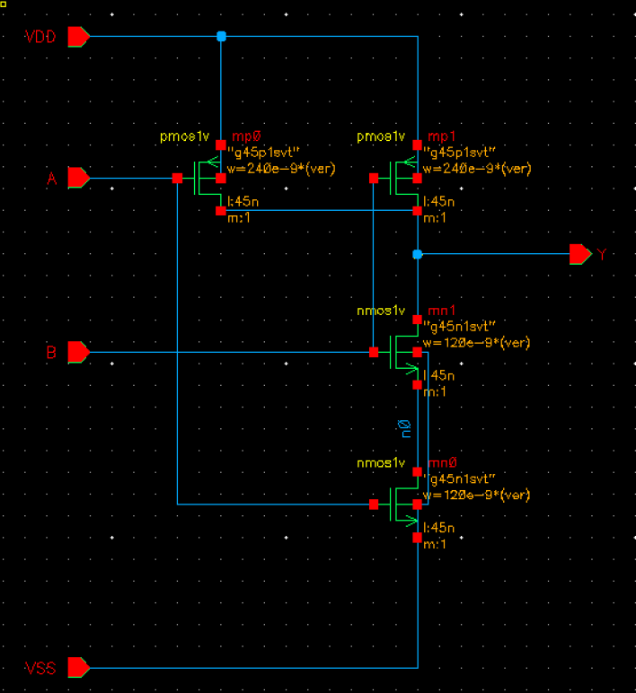

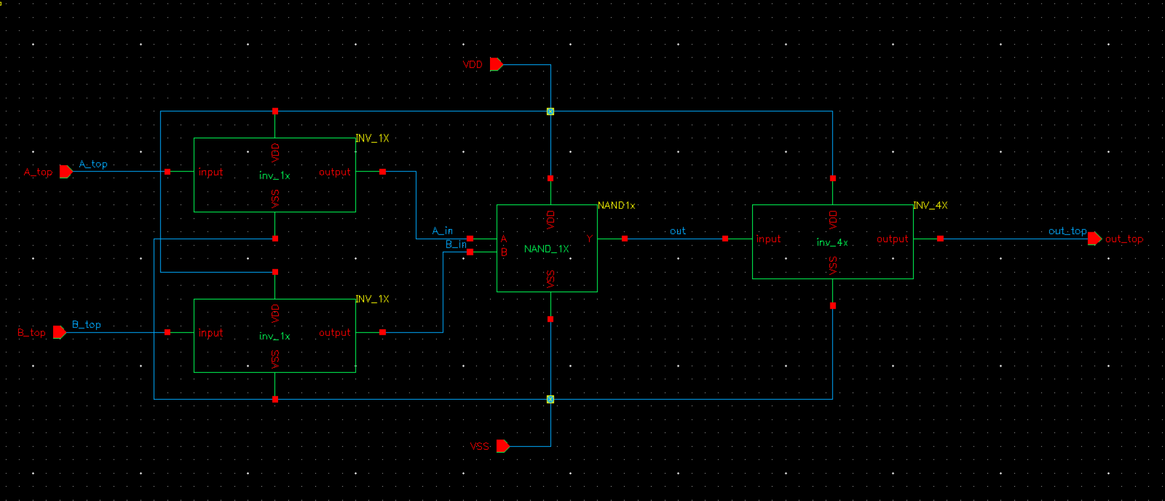

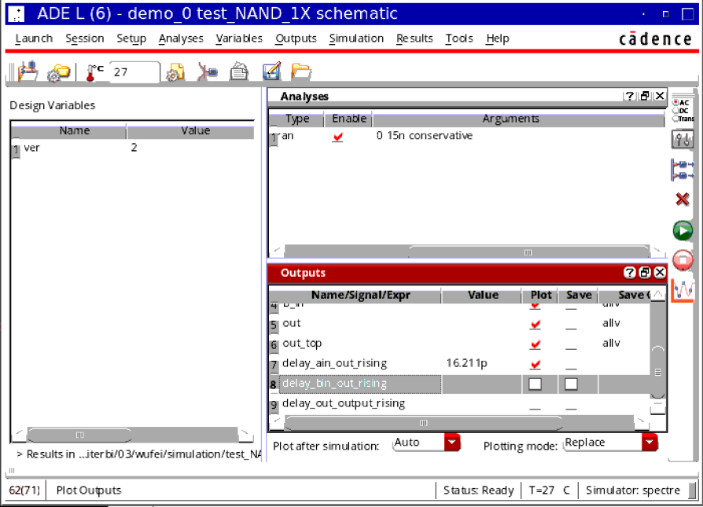

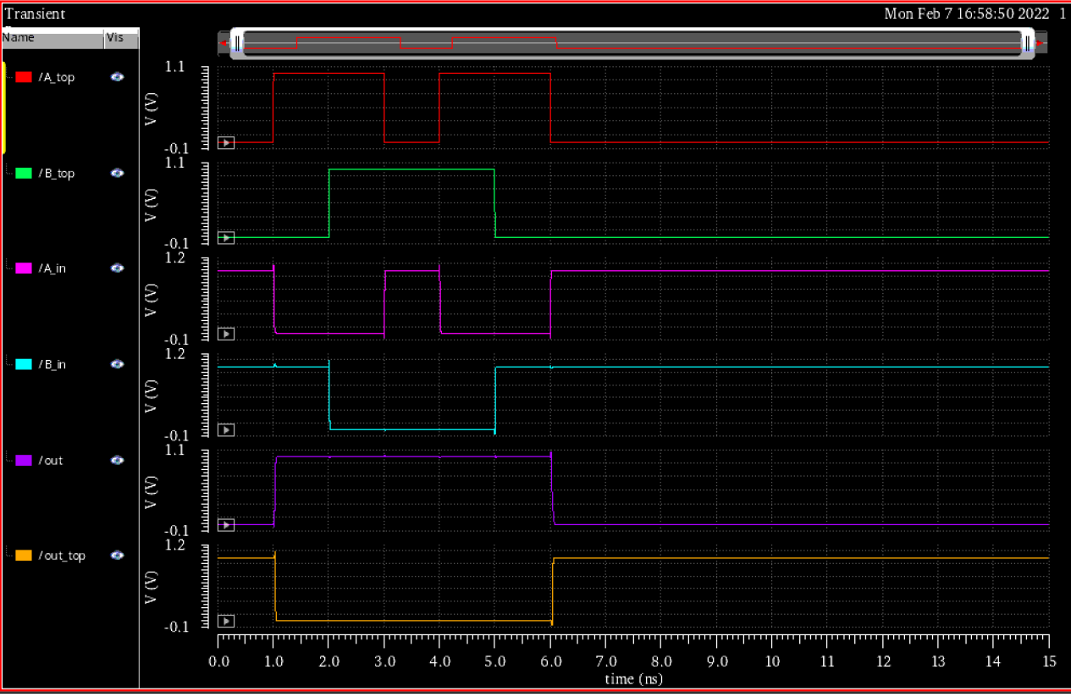

NAND4x:

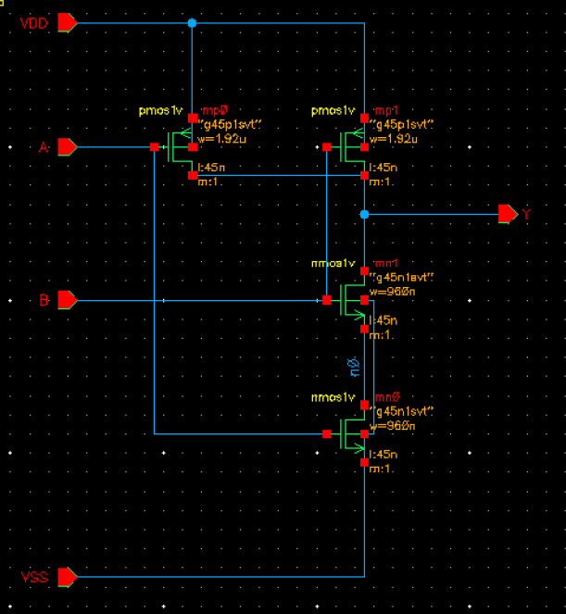

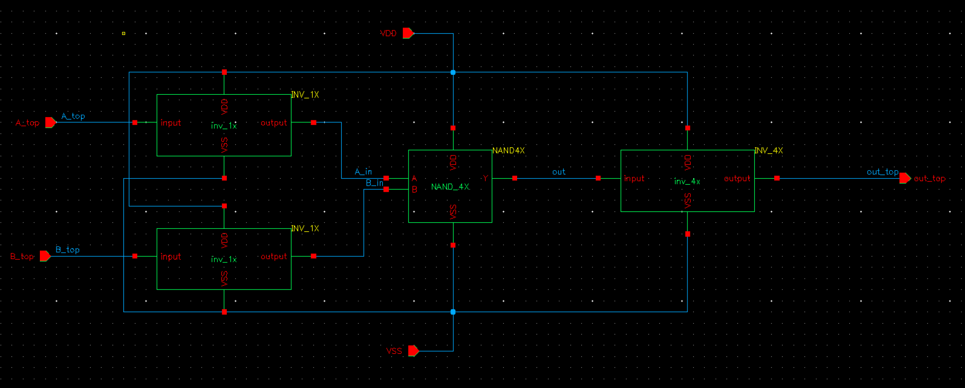

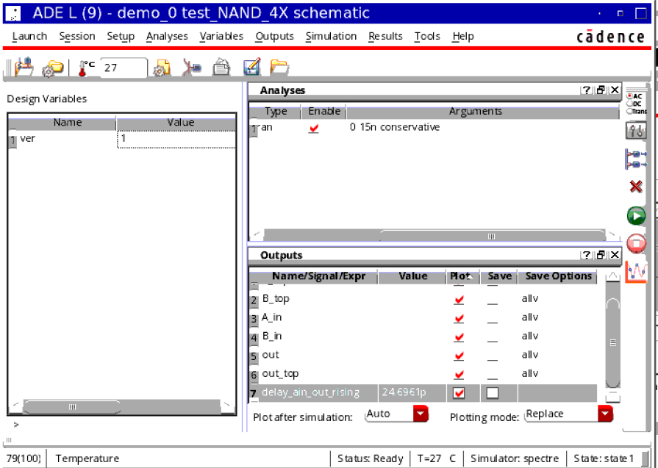

NOR1x

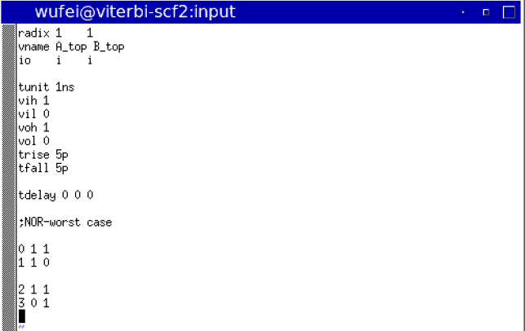

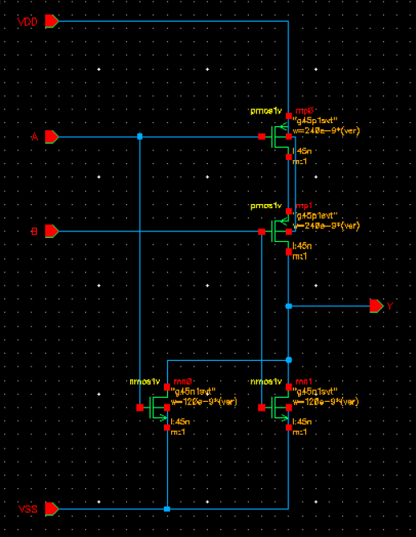

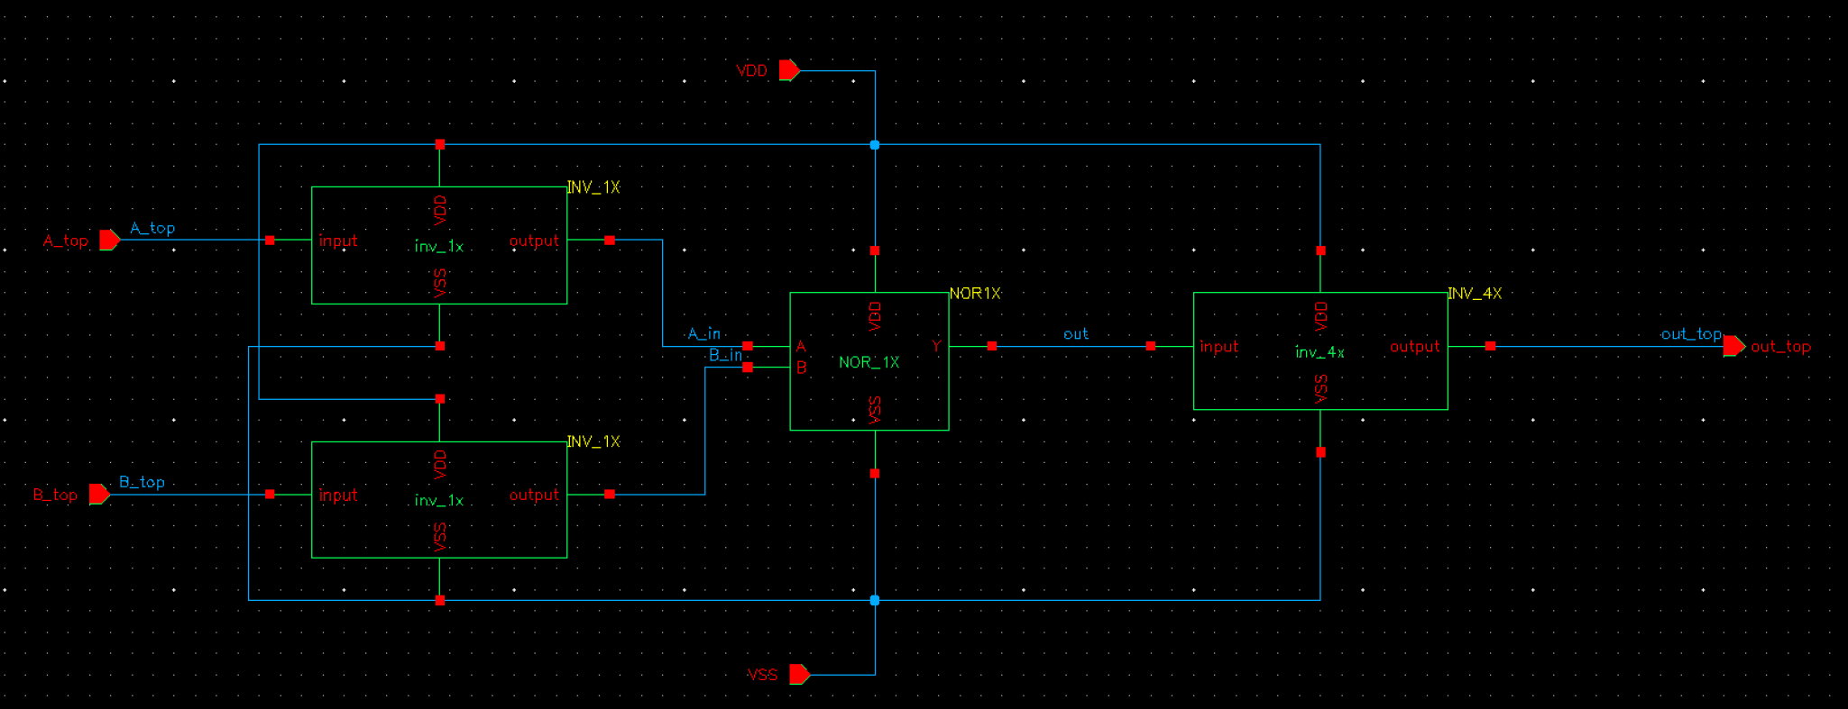

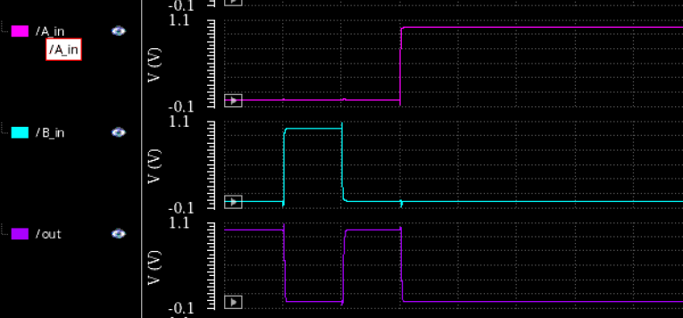

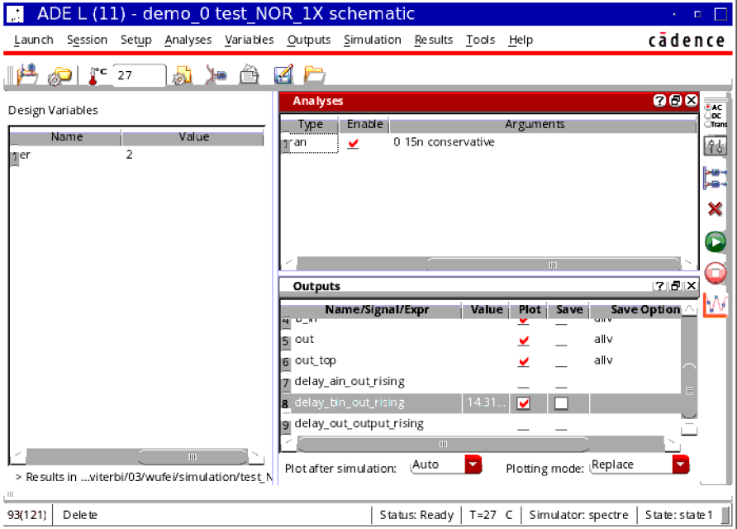

NOR4x

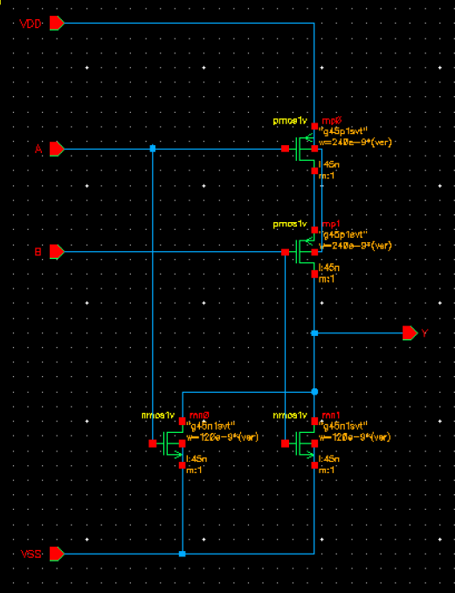

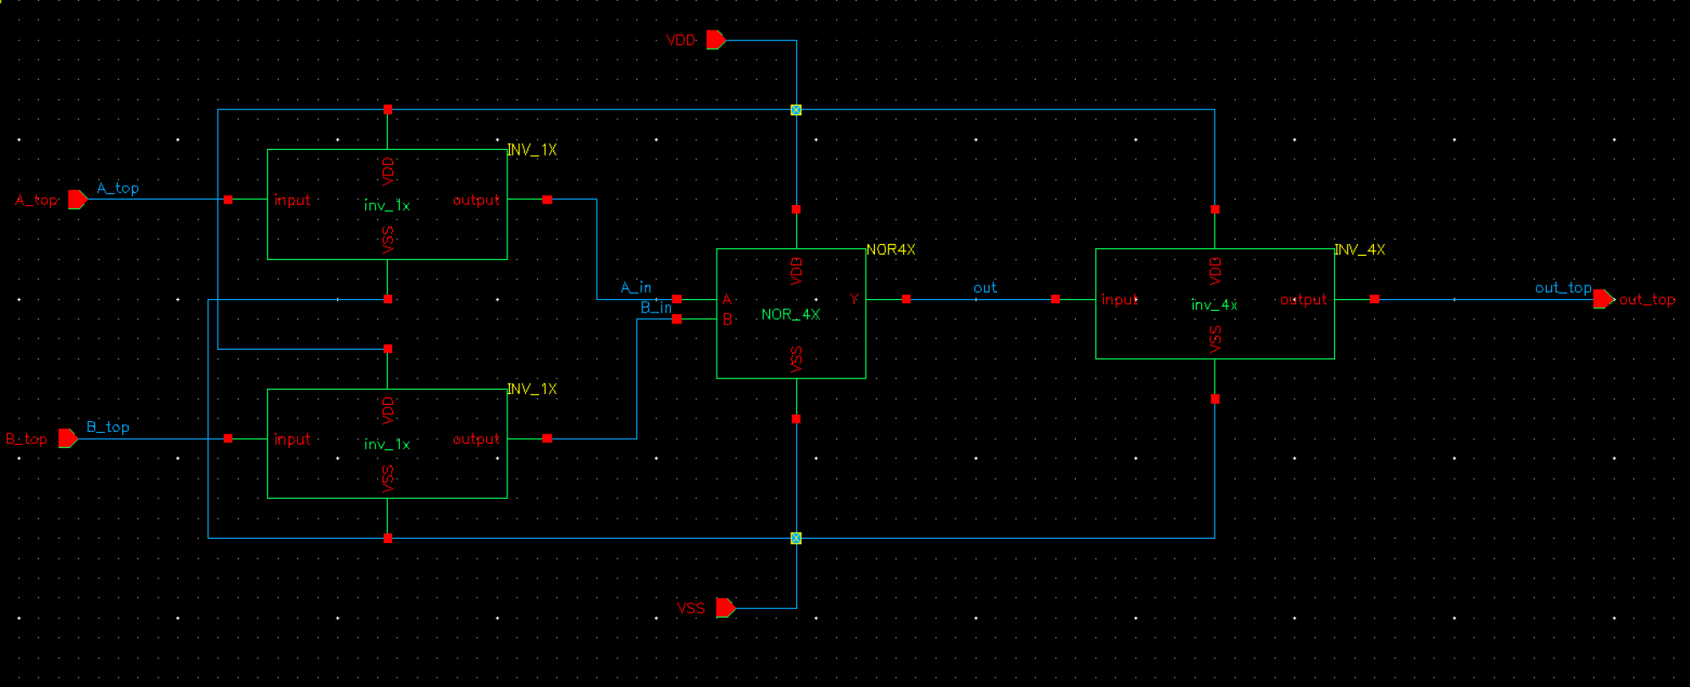

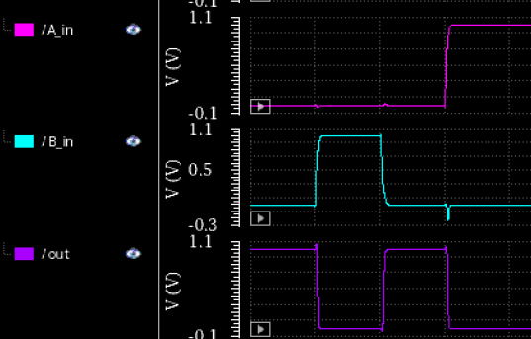

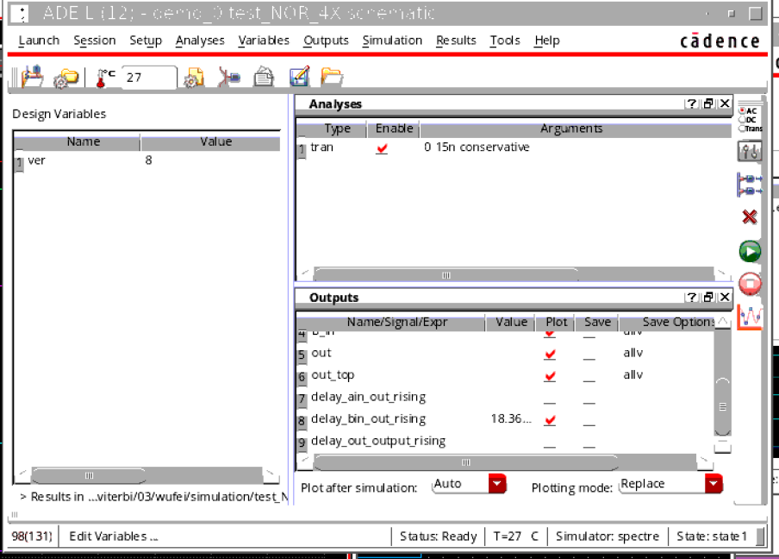

# Step4/Step3

Layout design:

* Draw layouts for all the 6 gates and their delay measurement testbenches (i.e. INV_1X connected to inputs and INV_4X to outputs).
* Perform DRC and LVS checks with the respective schematics.
* Find the rising and falling propagation delays. You’ll find they are different from the schematic. Think about the reason.
* Repeat Step 3 functional verification for the layouts.

## INV1X

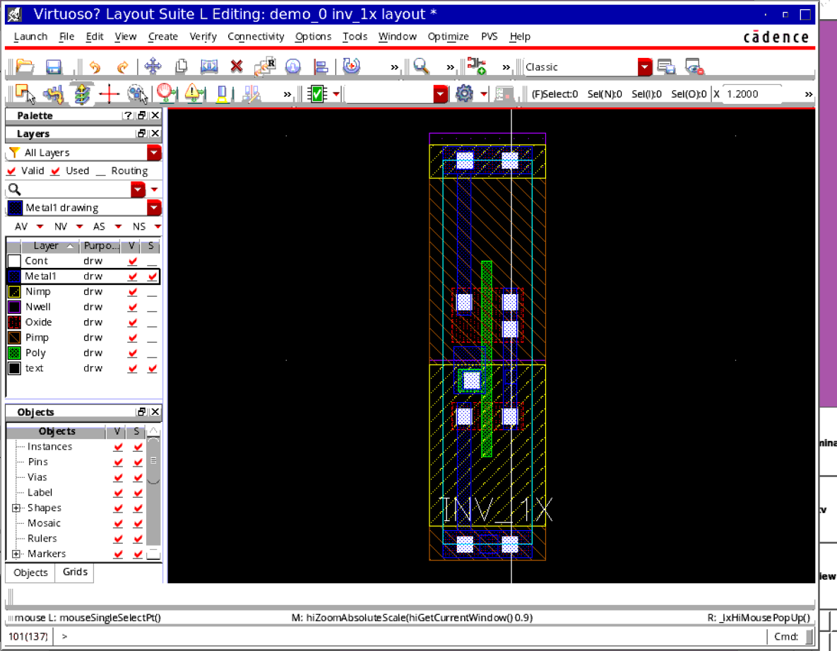

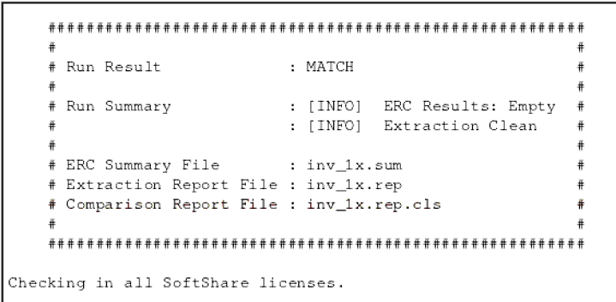

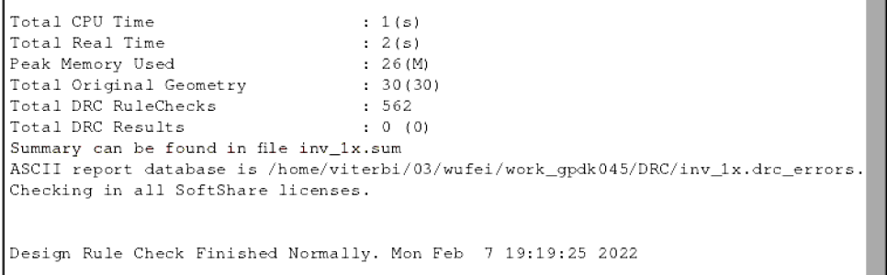

## INV4X

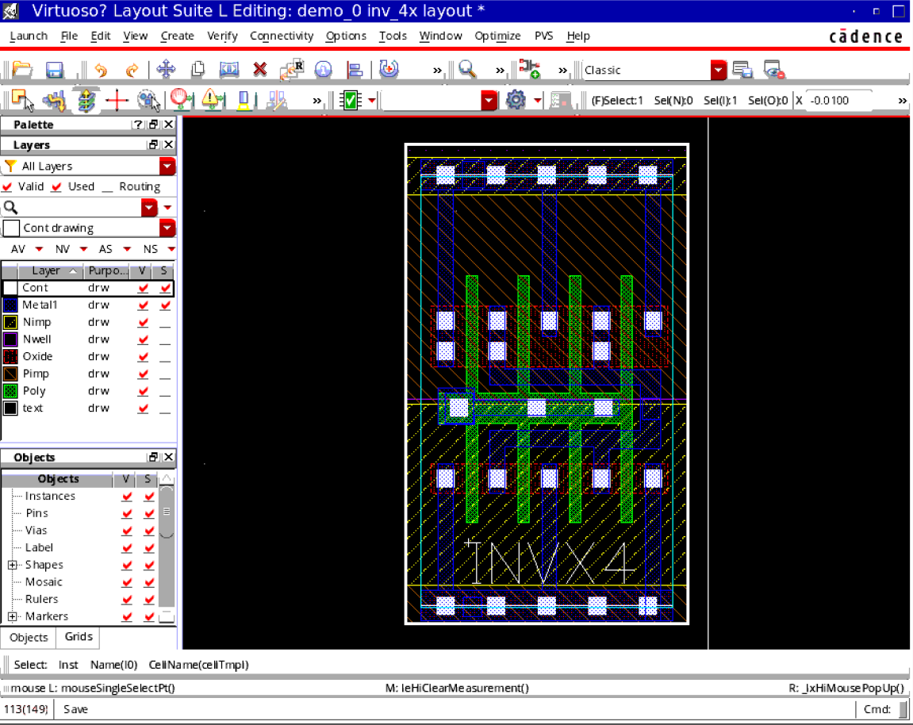

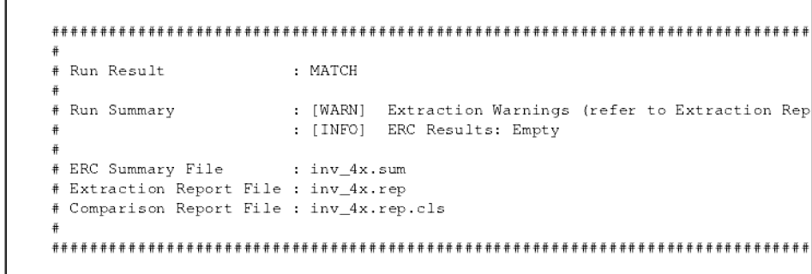

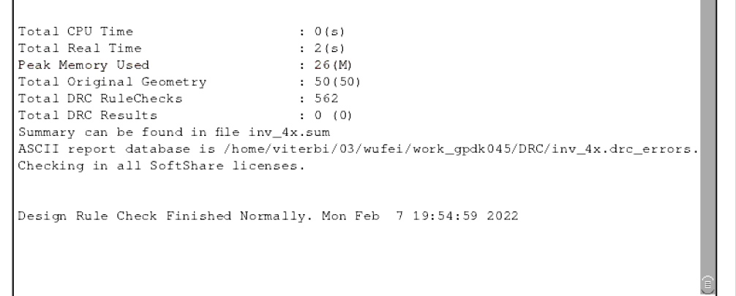

## NOR1X

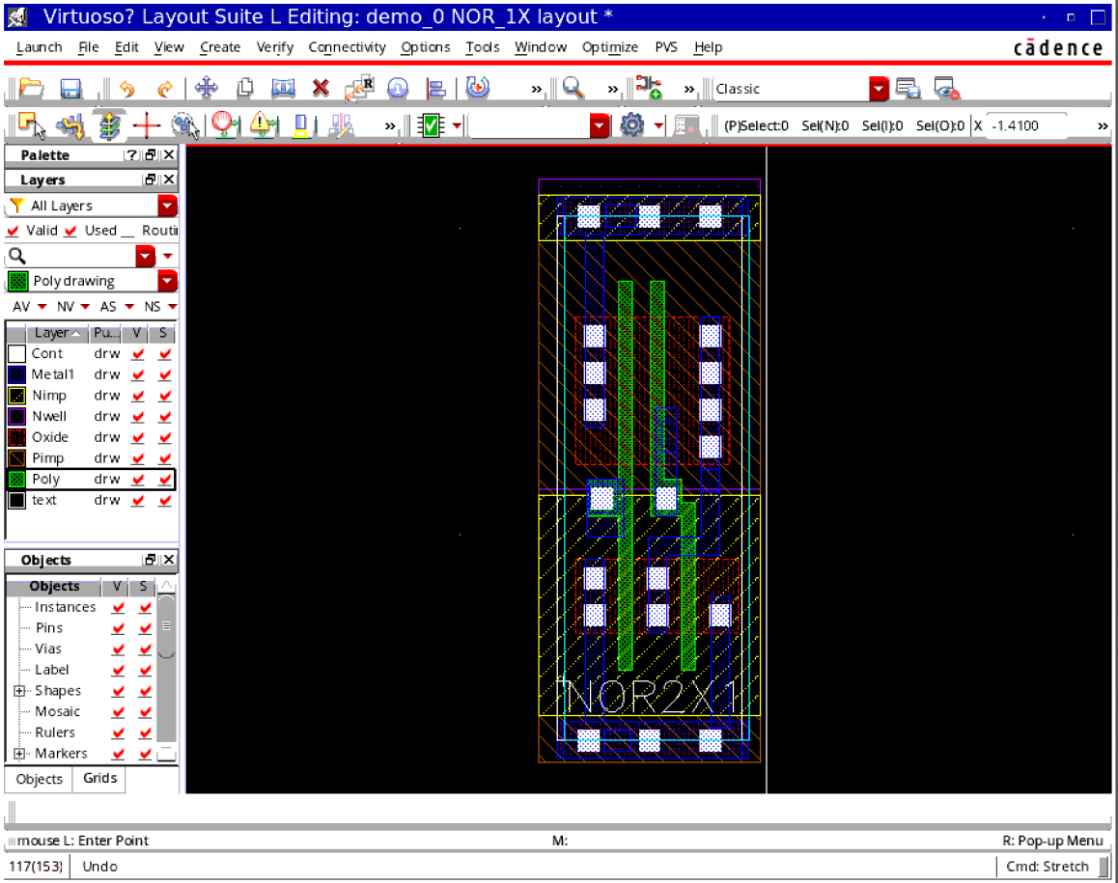

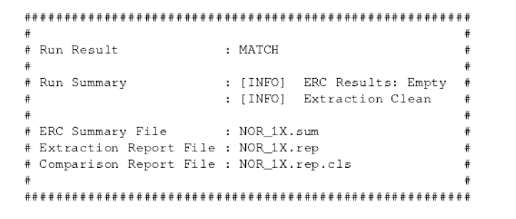

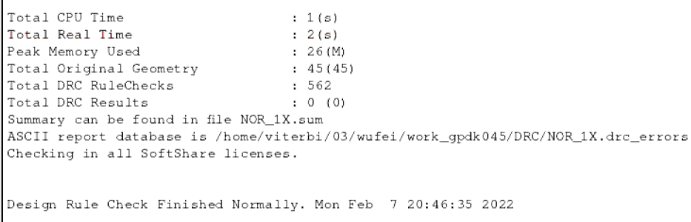

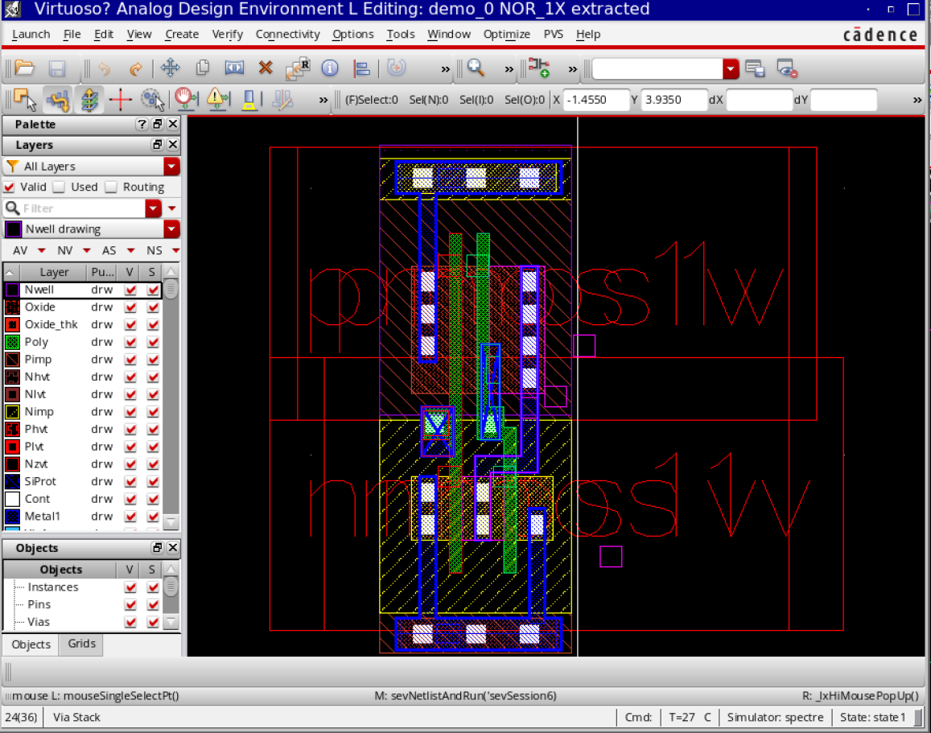

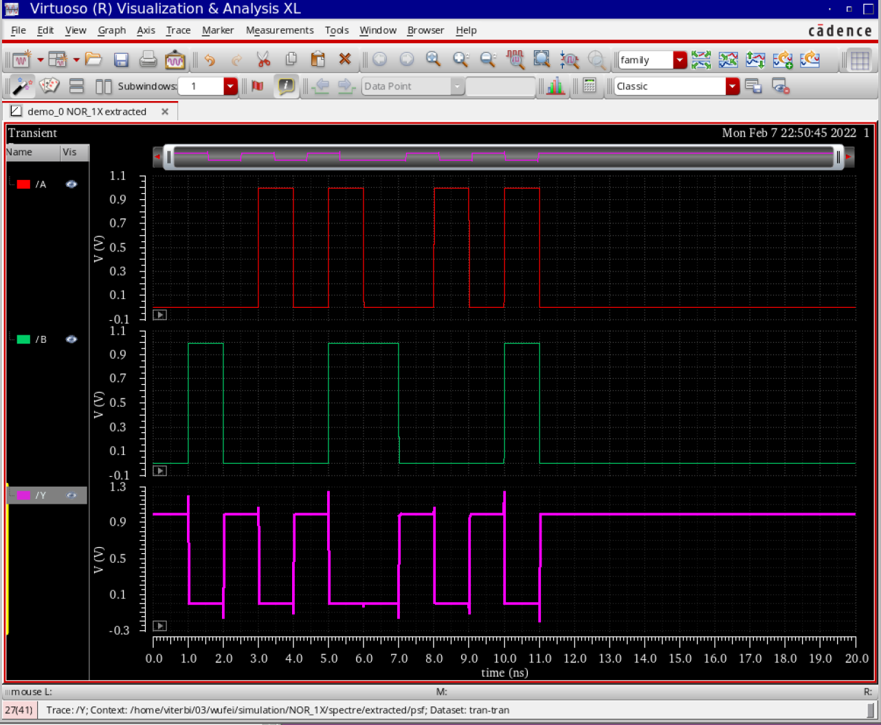

## NOR4X

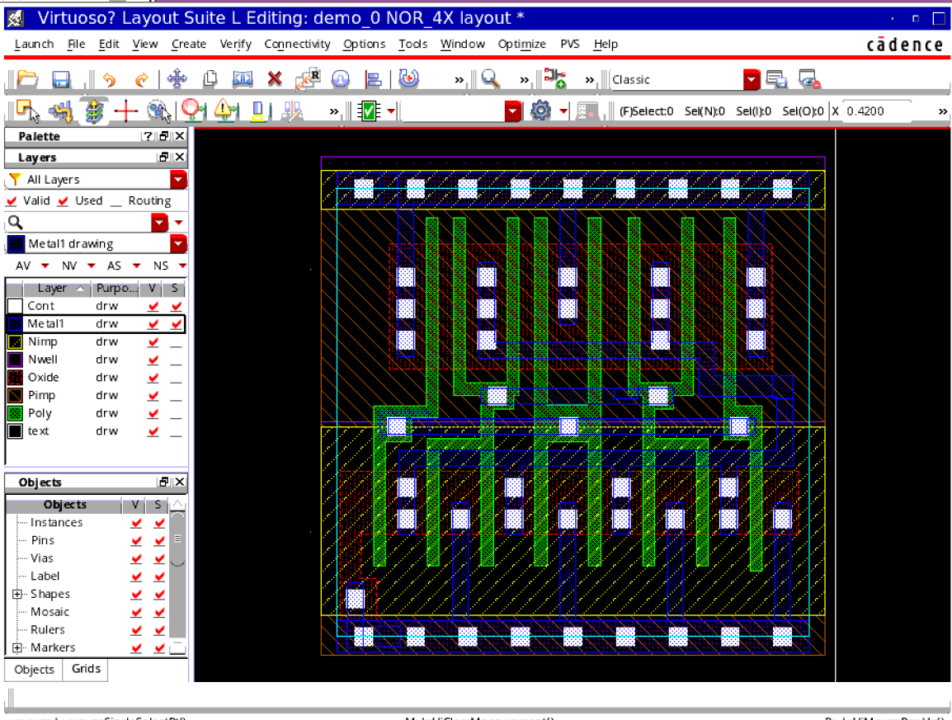

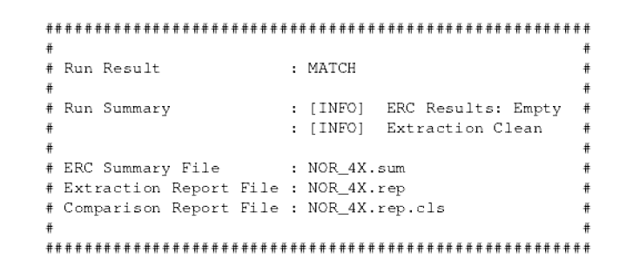

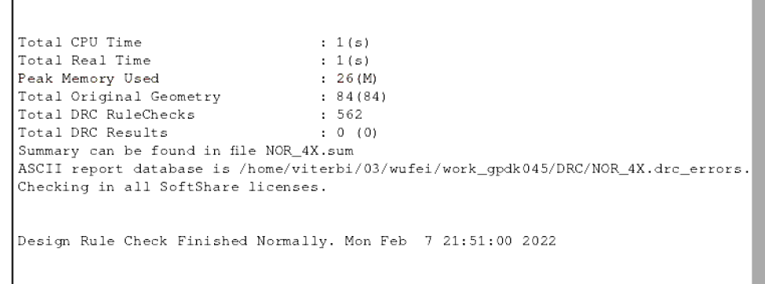

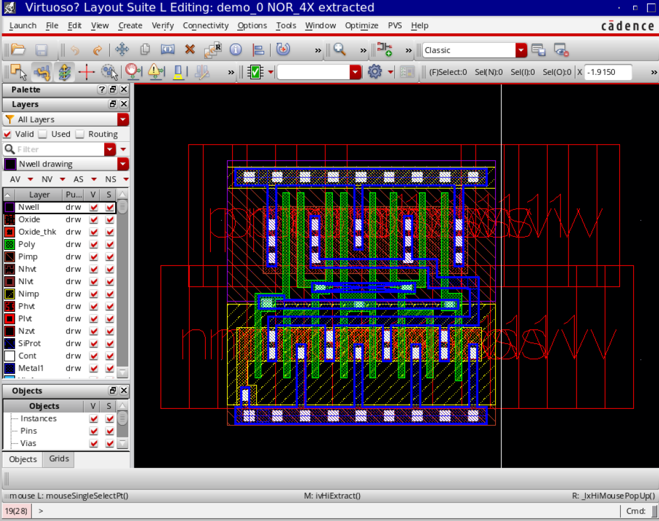

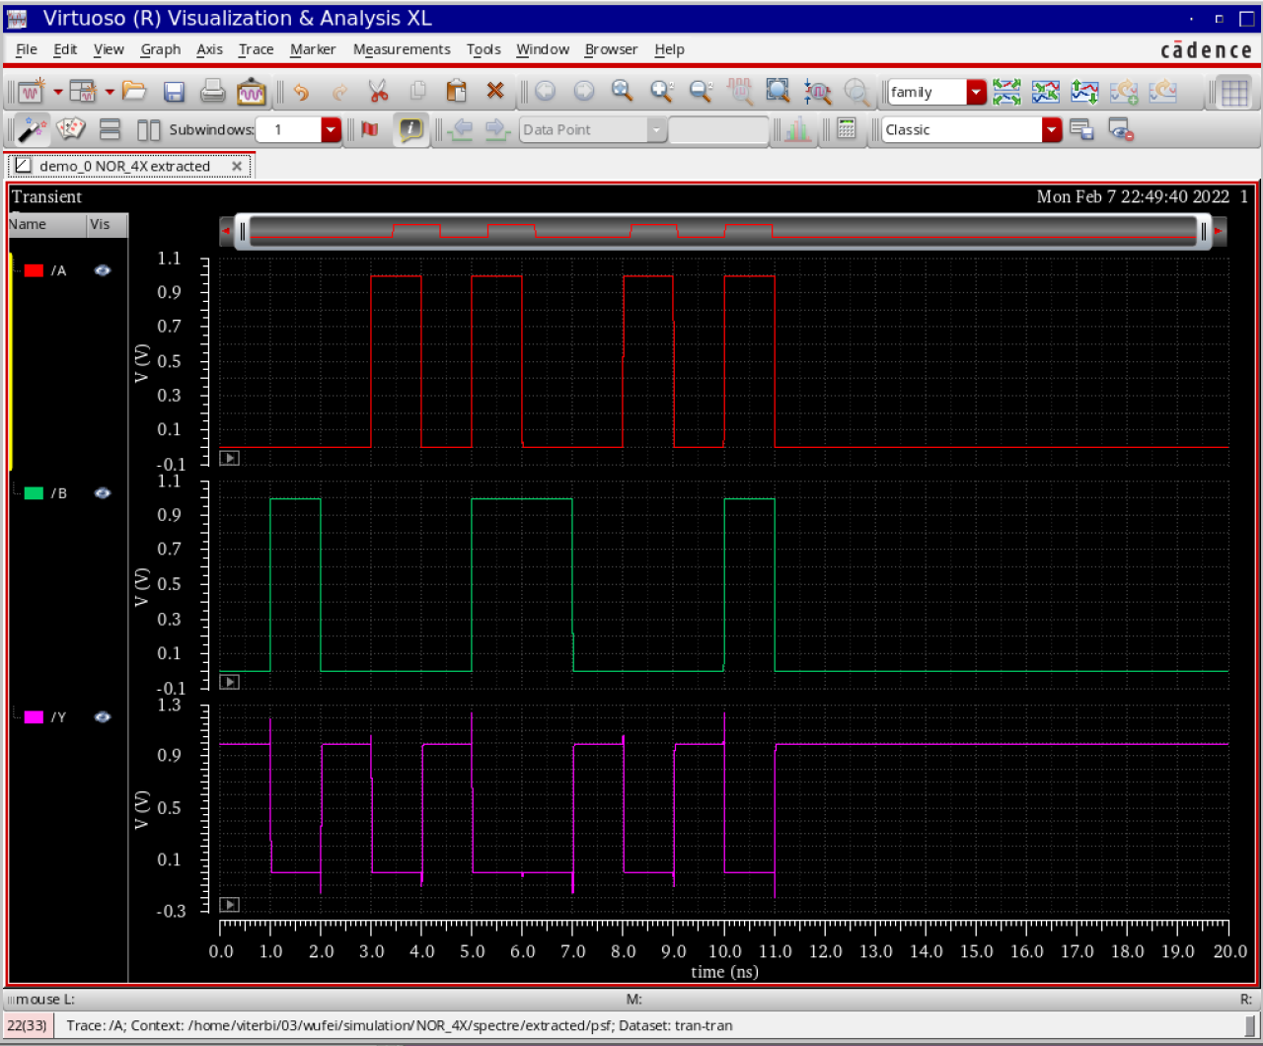

## NAND1X

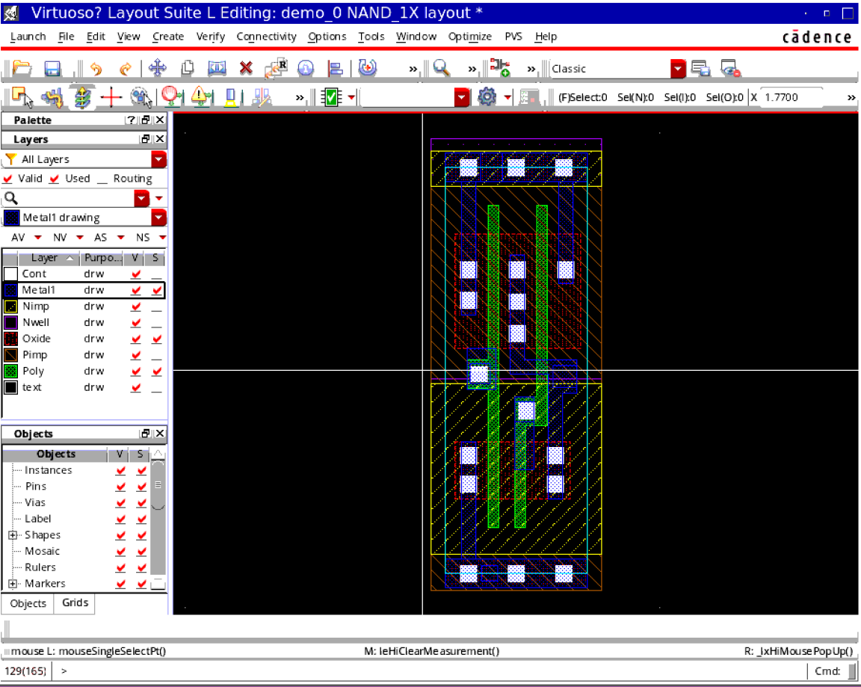

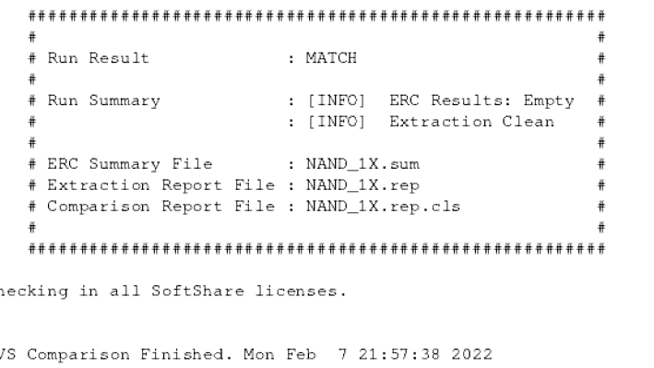

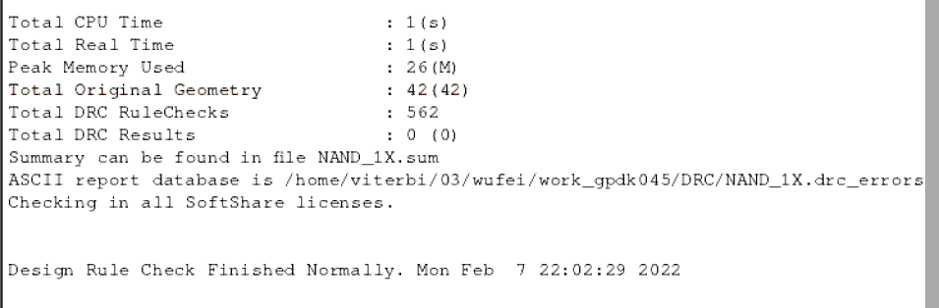

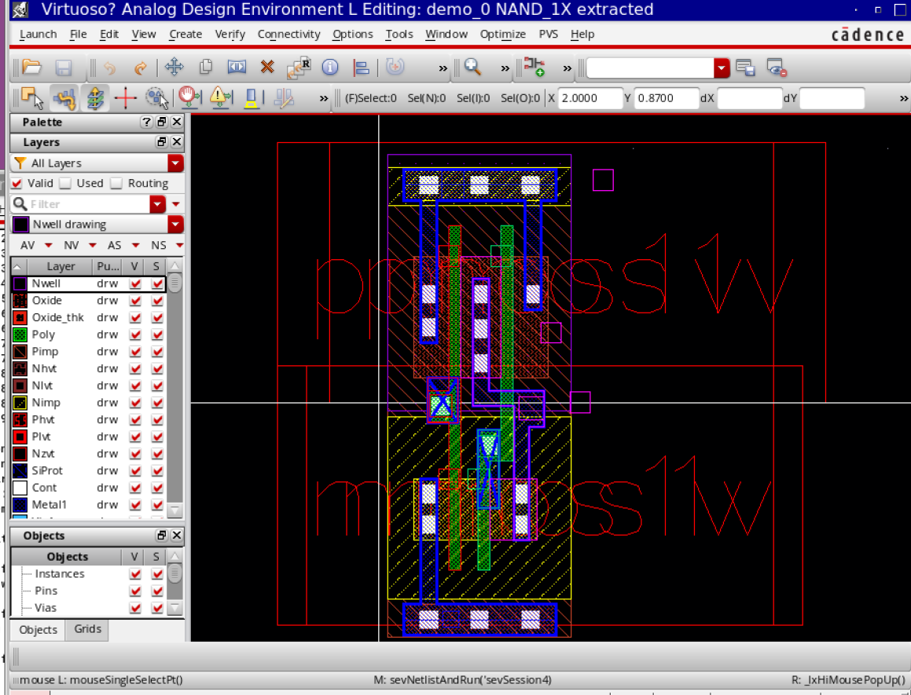

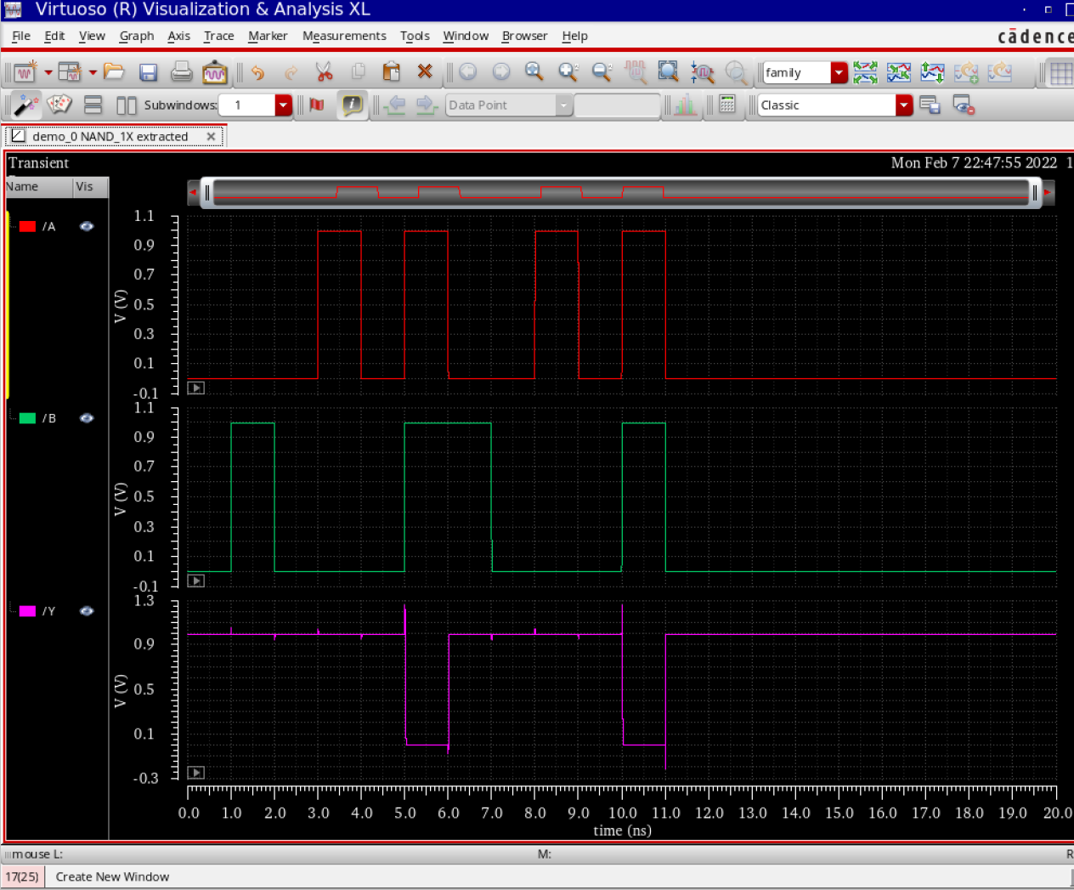

## NAND4X

